**Assignment 2**

**Calculate the CPU load for your machine and identify the state (under loaded or overloaded) of your machine. You have to find out the CPU usage of your computer using some Unix command.**

**Hint: With the help of grep Unix command, you can extract CPU usage. If CPU load is greater than 70% than it is overloaded, if it is between the range of 30% to 70% than it is moderately loaded and if it is less than 30% than it is lightly-loaded.**

**Program:**

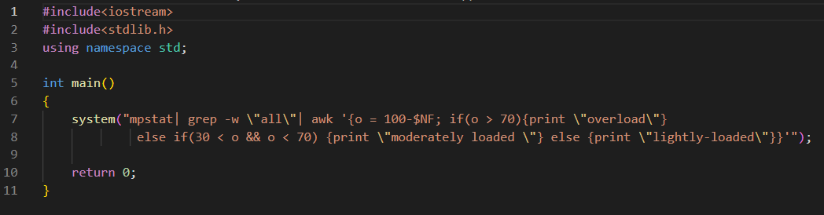

**Output:**

